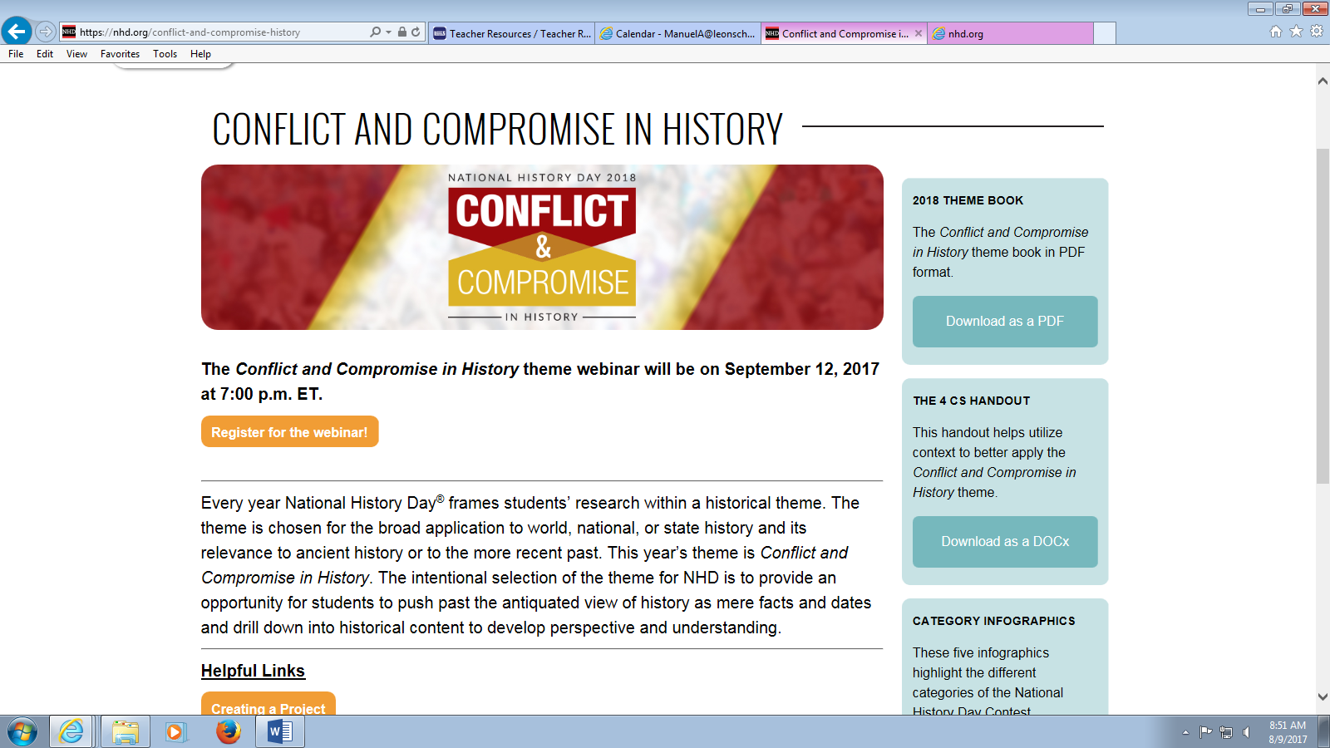
Deerlake Middle School
History Fair Timeline*
2017-2018

*Please note that the following dates are subject to change and may vary slightly according to your teacher’s specific calendar.

Introduction to History Fair: August 21st

- Resources Presentations (Learning Commons): August 28th -31st (Scheduled by teacher)

- Signed Parent Letter Due: Friday, September 8th

- Preliminary Topic Due Date: Friday, September 22nd

Official Topic Due Date: Monday, September 25th

Note: Each student/group will complete the Topic Info Form with the following information on it:
1. Individual or group members’ name(s)
- Project Topic
- Project Type
- At least 5 Sources (title, author)
– You will have time in the Learning Commons to complete this!

Learning Commons Research Days: Scheduled by teacher (October – December)

- Computer Lab Work Days: Scheduled by teacher (October – December)

- In Class Work Days: Scheduled by teacher (October – December)

Rough Draft Annotated Bibliography Due: Friday, November 3rd
  - All History Fair Projects must have a minimum of 10 sources, at least 3 of which are primary sources. At least one source should also be a print source. Students may add to their bibliography as research continues.

- Rough Draft of Process Paper Due: Thursday, November 9th
  - Must contain all required components.

    - Final Draft Process Paper & Bibliography: Tuesday, January 9th
    - Completed Display Board Due: Wednesday, January 17th
    - Completed Media/Website/ Performance: Friday, January 19th
    - DMS History Fair Set-up in Learning Commons: Monday, January 29th
    - DMS History Fair Judging: Tuesday, January 30th
    - DMS Social Studies Classes View Projects: Wednesday, January 31st
    - Projects removed from Learning Commons: Wednesday, January 31st
    - Leon County History Fair: Friday, February 23rd

